**Lead in**



* Have you ever applied for a job in the tech industry? If yes, what was your experience? If not, what type of job would you like to apply for in the future?
* What skills do you think you need to have in order to be good at that job?
* Which of the following documents are job applicants usually asked for: application form; biodata; cover letter; resumé or CV? Have you ever written one of these documents in English?

Listening practice

*1. Listen to Andrew Ng, Computer Science Faculty Member at Stanford and co-founder of Coursera. He is discussing patterns for success in the field of Machine Learning.*

*Select information to answer the following questions:*

1. What do recruiters look for?
2. What makes a desirable candidate?
3. What example of pattern strategy for successful careers can you refer to?

*2. Summarize the career advice discussed above and define what is a “T-shaped individual” and how that relates to the factors that help convince recruiters.*

*Take the discussion further and hypothesize about possible “failure modes” (unsuccessful ways of navigating a career)?*

.

*3. Check out the following diagrams and match them with particular types of successful/unsuccessful career building patterns.*

c

c

**c**

**c**

c

c

c

c

c

c

c

**c**

**c**

a.

c

c

c

c

c

d.

c

c

c

c

c

c

c

c

c

c

b. c.

*4. The following phrases have been used in the video to describe two specific aspects of learning. Explain what they refer to and use them in a meaningful context.*

Depth of knowledge

Breadth of knowledge

1. *Study these job requirements and try to match them to the list of jobs which follows.*

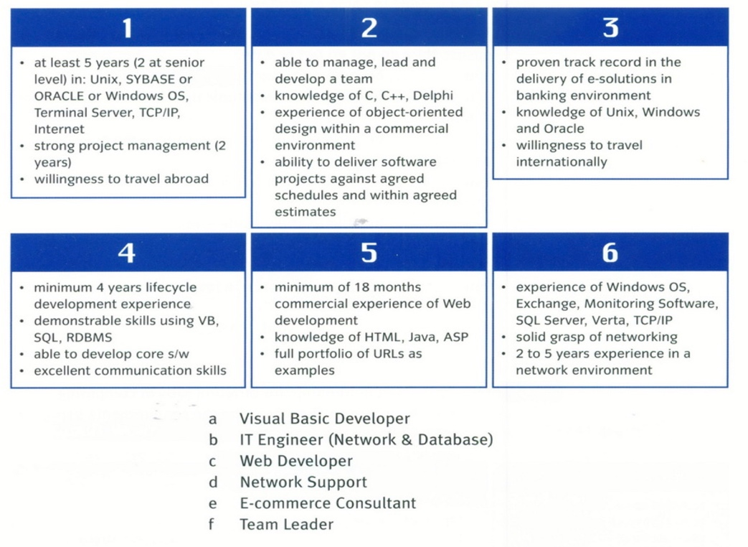

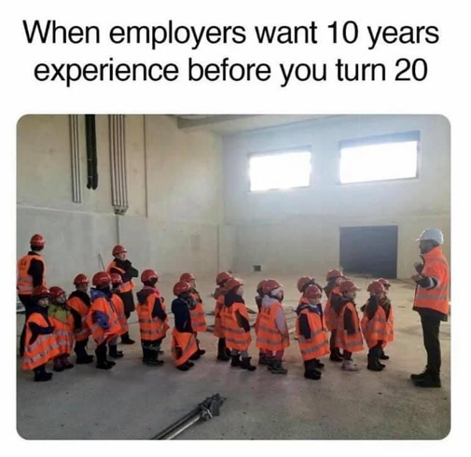

**Language work – Structures used for requirements**

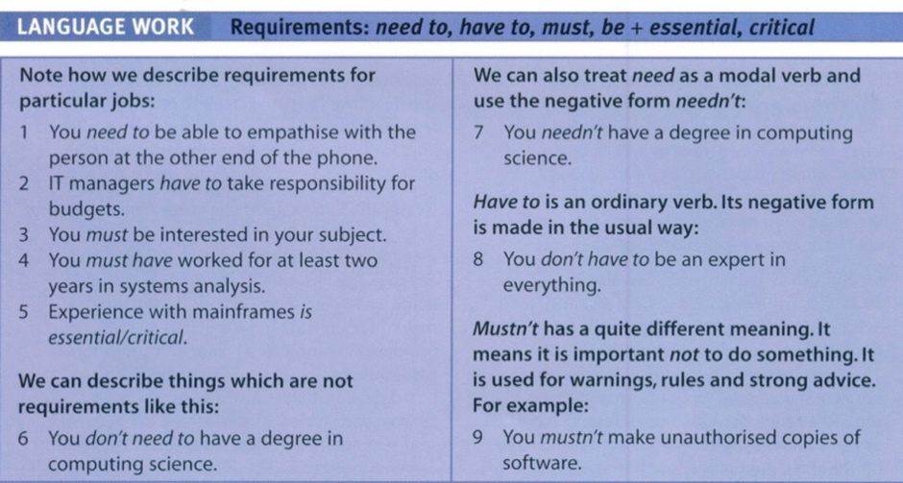

#### Also you can formulate requirements using shall, like in the examples below:

* The system shall operate at a power level of…
* The software shall acquire data from the…
* The structure shall withstand loads of…
* The hardware shall have a mass of… or
* The in-vehicle infotainment system shall be compatible with the following devices…
* The Monitor shall set <Overtemp Alert> to TRUE within 0.5 seconds .

Remember **shall** is mostly used to describe **formal obligations**:

* You shall wear your badge at all times.
* Applicants shall come to the interview with their CVs and copies of their qualifications.

Don’t think of **shall** as a word, rather as an item that says **requirement**!

In statements of work (SOW), standards, regulations, process requirement documents that contain requirements on the organization producing a system/product/application “**should”** is also used to communicate a “best practice” that is recommended if applicable but is not mandatory.

* The application should minimize life cycle costs.

Facts and declaration of purpose - **Will** is used to indicate a statement of fact, a planned development.

Will statements are not subject to verification.  For example,  if I want to tell you something about another system I will use “will”.  “The XYZ system will have the timing as defined in an ICD 1234.”

In job advertisements - **Would** is used for desirable, but not essential criteria.

For example: Knowledge of C++ would be an advantage.

*1. Fill in the blanks with the appropriate form of the verbs: will, shall, should, need to, have to, have to and must.*

1. Technical qualifications .....be renewed at intervals to ensure they do not go out of date.

2. You .....become an expert in too narrow a field.

3. You .... good communication skills to become an IT manager.

4. You .... an expert in hardware to become a programmer.

5. You .... have worked with IBM mainframes for at least two years.

6. You .... to be able to show leadership.

7. You .... have a degree but it ..... be in computer science.

8. You ..... to have experience in JavaScript.

9. You ..... to be able to use C++.

10. These days you .... study BASIC.

11. As a Vision Intern at Intozi Tech, the candidate ..... develop computer vision capabilities for the company's core platform.

12. You ...... be a versatile hardware engineer with experience implementing embedded systems to be considered a desirable applicant.

13. Once the applicant has expressed his agreement with the letter of engagement, METAS- Cert ....... undertake a material check of the application. METAS-Cert ..... inform the applicant on the result of the testing.

14. The Data Architect ...... work as an integral part of an Agile team to design and implement the data strategy and architecture underpinning our Digital Products.

*2. Study these requirements for different jobs in computing and describe them using the methods studied above.*



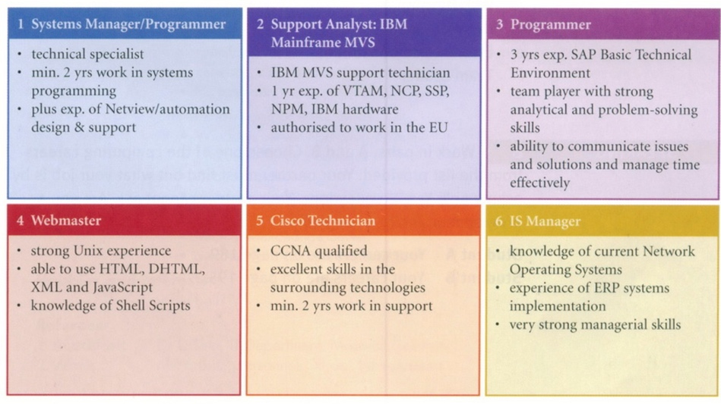

Extension activity

*1. Work in small groups / teams. Together with your team members, create an imaginary*

*company, and write a short job advertisement for a position in the company.*

Make sure to include:

● some information about the company (name, what you do, what is your motto, etc.)

● information about the job (job title, nature of work, formal qualifications, personal qualities, technical skills, etc.)

Post your job advertisements on the Class Collaborative Notebook, depending on when you will hold the interviews. At the end of the session, each team will have to present their offers.

